

Privileges

By : Techuva Solutions

## Index

|  |  |  |
| --- | --- | --- |
| S.No. | Privilege Roles | Page No. |
|  | HO Coordinator | 2 |
|  | Dynamic Levels | 2 |
|  | 1. Managing Director | 3 |
|  | 1. VP- Finance | 3 |
|  | 1. VP- Operations | 4 |
|  | PPC | 4 |
|  | Factory QC | 5 |
|  | Factory Invoice | 5 |
|  | Factory Logistic | 6 |
|  | Factory Scrap Inward & Ts | 6 |
|  |

## HO COORDINATOR:

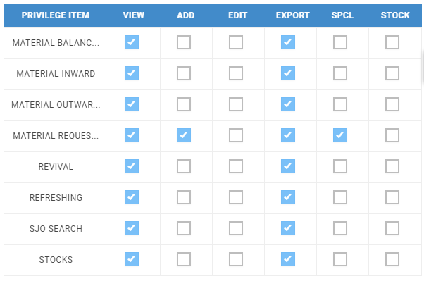

|  |  |
| --- | --- |
|  | HO-Coordinator Roles and responsibilities |
| 1 | Requests factory for materials based on tickets or buffer. (The only tickets which will be visible to the HO-coordinator will be the ones approved by the Technical Service (TS). |
| 2 | The material type (new/revived) must be selected by the HO-coordinator |
| 3 | Any material request if rejected by the MD/VP-Finance/VP-Operations goes back to the HO- Coordinator for reviewal and further action. |
|  |  |

**Request against Tickets ID:**

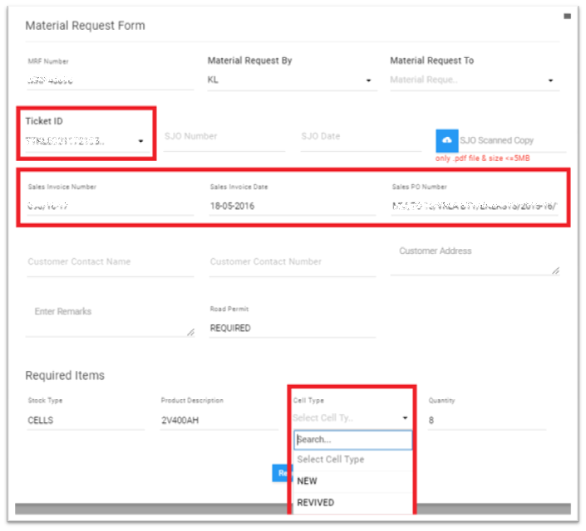

**Request against Buffer:**

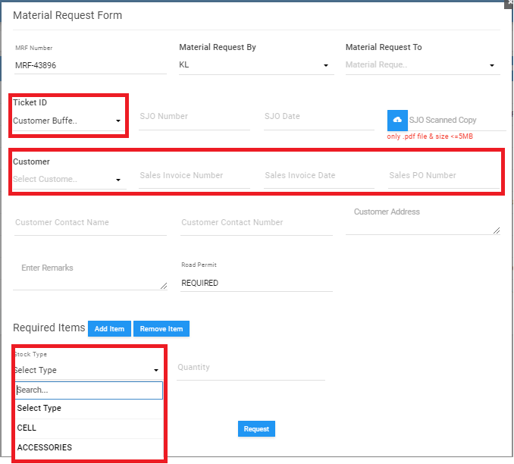

## DYNAMIC LEVELS:

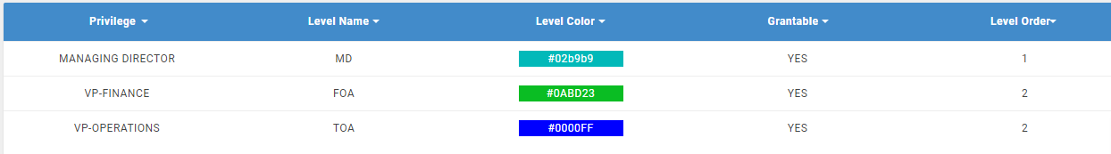

* These levels are dynamic i.e., we can turn off as well as turned on the levels at any position.
* We can change the order of the levels also.

## MANAGING DIRECTOR:

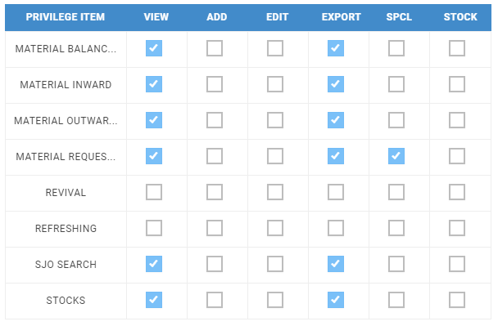

|  |  |
| --- | --- |
|  | MD Roles and responsibilities |
| 1 | Requests raised by HO-Coordinator goes to the MD who takes the following decisions: -   * Approve the request. * Reject the request. * Hold the request. |
| 2 | IT is only the MD in the dynamic levels who has the privilege to see all types of material requests (new/revived cells & accessories) |
| 3 | He also has the privilege to act on a raised request through email as well. If a request is rejected by the MD, it is sent to the HO-Coordinator as an acknowledgement, and if accepted, it goes to the VP- Finance & VP- Operations. Any one of them can take the further action. |
|  |  |

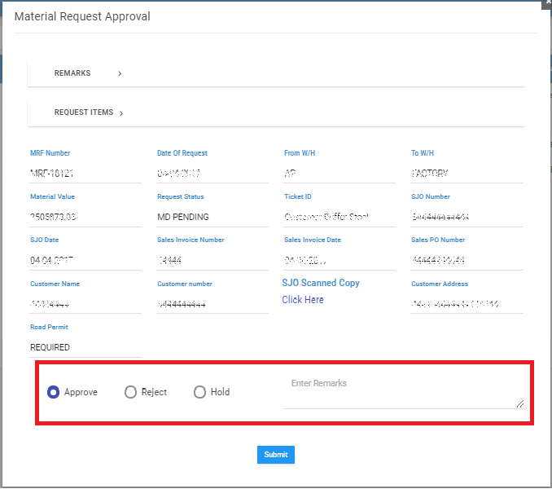

## VP-FINANCE

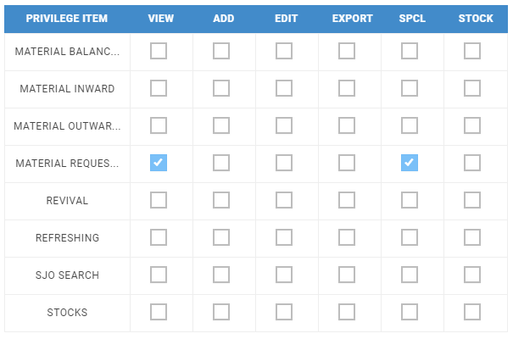

|  |  |
| --- | --- |
|  | VP-Finance Roles and responsibilities |
| 1 | Requests accepted by MD comes to the VP-Finance who takes the following decisions: -   * Approve the request. * Reject the request. * Hold the request. |
| 2 | VP- Finance can only see the new cell requests. |
| 3 | Among VP-Finance and VP-Operations, only one can act on a request. Once the request has been entertained by any one of the two, it gets disabled for the other one. |
|  |  |

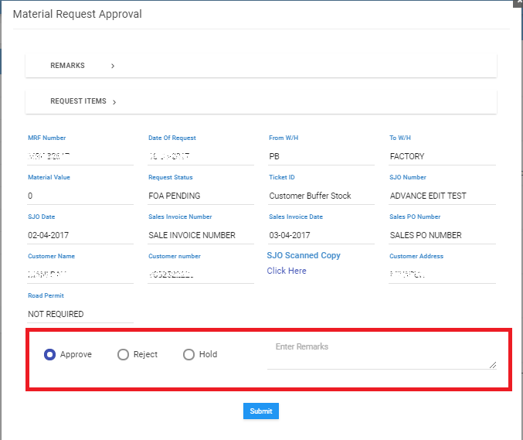

## VP-OPERATIONS



|  |  |
| --- | --- |
|  | VP-Operations Roles and responsibilities |
| 1 | Requests accepted by MD comes to the VP-Operations who takes the following decisions: -   * Approve the request. * Reject the request. * Hold the request. |
| 2 | VP- Operations can only see the new cell requests. |
| 3 | Among VP-Finance and VP-Operations, only one can act on a request. Once the request has been entertained by any one of the two, it gets disabled for the other one. |
|  |  |

## C:\Users\Techuva\Desktop\Untitled.png

## PPC

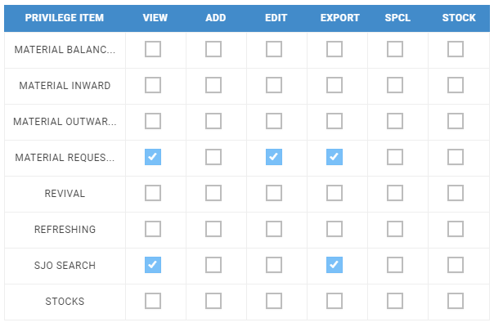

|  |  |
| --- | --- |
|  | PPC Roles and responsibilities |
| 1 | After the request has been approved, it is the PPC which gives the readiness date of the material that is to be shipped to the client. |
| 2 | PPC also gives a re-readiness date if there is an overdue. |
| 3 | If only a fraction of the entire requested material quantity gets the readiness date, then till the time the fractional quantity does not get received at the warehouse, it is in the pipeline (In Transit). Now since a single SJO number is allotted to the entire request on the whole, the remaining order quantity will not get the readiness date till the time the status of the partial quantity is not ‘partially closed’. The status remains ‘Partially Closed’ till the time the entire request quantity does not reach the warehouse. |

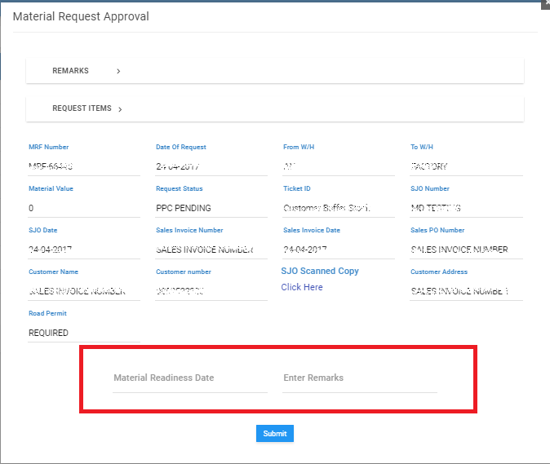

## FACTORY QC

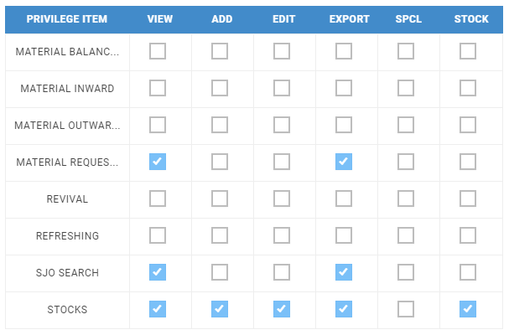

|  |  |
| --- | --- |
|  | Factory QC Roles and responsibilities |
| 1 | Factory QC views the SJO number of a given request as per the readiness date if it is not overdue. |
| 2 | Factory QC gives individual unique cell serial numbers to all the cells for which readiness date has been defined by the PPC. |
| 3 | In case of bulk material upload (>500), the system asks to import the stock via an excel file. |

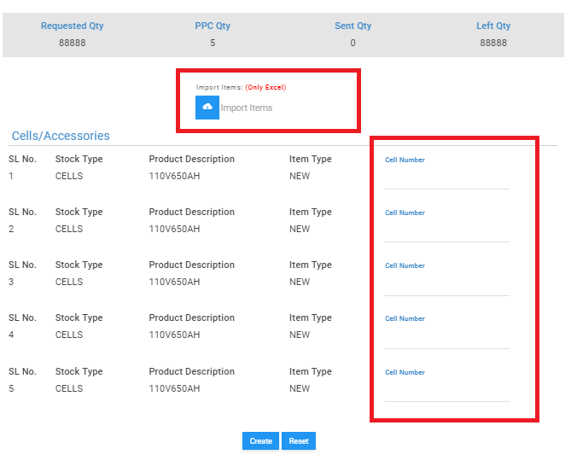

## FACTORY INVOICE

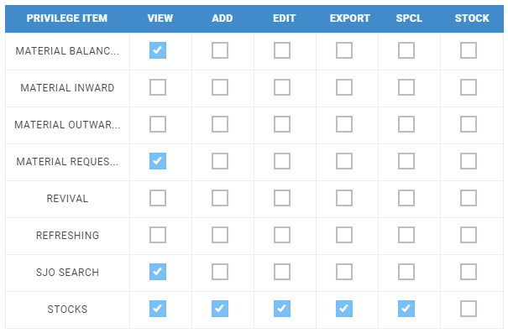

|  |  |
| --- | --- |
|  | Factory Invoice Roles and responsibilities |
| 1 | An Invoice number and invoice date is generated and allocated to the request having the cell serial number. |

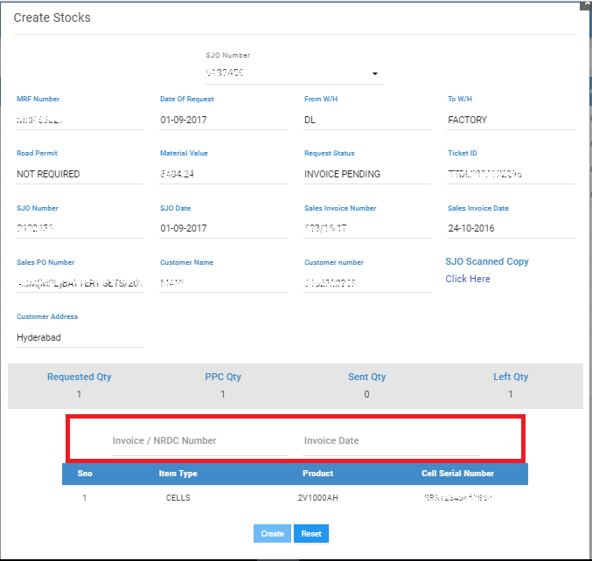

## FACTORY LOGISTIC

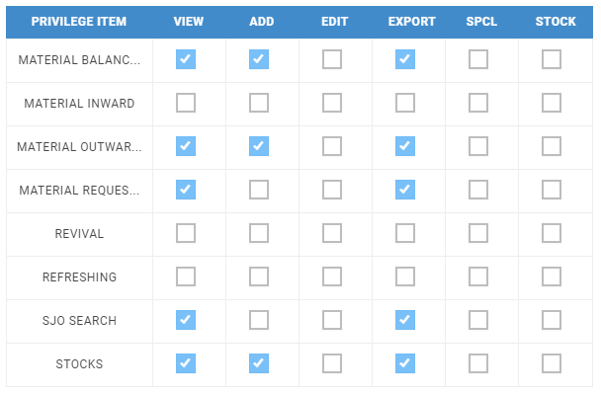

|  |  |
| --- | --- |
|  | Factory logistic Roles and responsibilities |
| 1 | They handle the shipment of the material to the warehouse which eventually goes to the client location. |

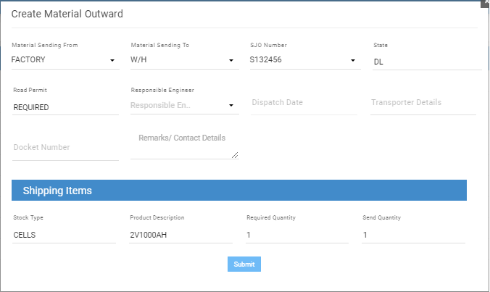

## FACTORY SCRAP INWARD & TS

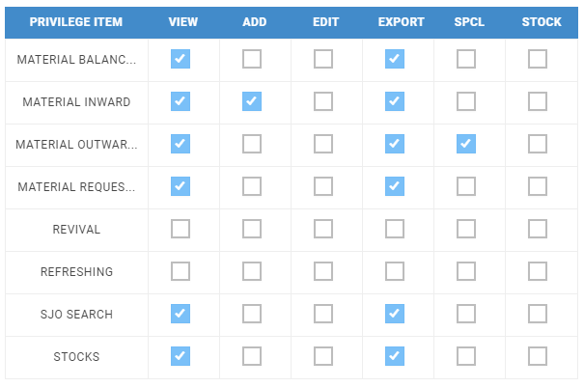

|  |  |
| --- | --- |
|  | Factory Scrap Inward & TS Roles and responsibilities |
| 1 | They handle the return of the faulty material from the client location to warehouse and eventually comes back to the factory. |

